**SENIOR TWO**

**GEOGRAPHY**

**PAPER 1**

**TIME: 2:45 HOURS**

**ST JOHN’S HIGH SCCHOOL KAWEMPE**

**END OF TERM II EXAMINATIONS 2024**

**S.2 GEOGRAPHY**

**TIME ; 2 HOURS**

**INSTRUCATIONS**

**Do all numbers**

**SECTION A**

**COMPULSORY QUESTIONS: MAP AND PHOTOGRAPHIC SKILLS**

**Item 1: map skills**

The residents of lukaya living south of northing 90 engage in different activities to earn a living. Mary, a university student who specialized in aquaculture decided to conduct her internship from this area. She was mostly interested in guiding the local residents on how best they could handle the fishing activity and at the same time conserve the environment.

**Support material: map of Lukaya**

**Task:**

1. Mary is interested in knowing the area covered by lake Victoria south of northing 86.help her to establish the area.
2. Chike works as a teacher at a school south west of Lusago (700858). He stays at Mpugwe (732844), he uses a taxi along the bound surface road to lukaya town (750844) which charges 500/= per km. From lukaya, he uses a bodaboda through a motorable truck road which branches off from 739844 and charges 1000/= per km to reach school.

Determine the total cost Chike uses to reach school.

1. Mary who lives in lukaya would like to know more about the geography of the area. Educate her on the same
2. Come up with an outlook of the area provided on the map extract and show the lake,rivers, swamps, settlement and foot path.

**Item 2: Photograph Skills.**

Trade areas in Uganda are mushrooming in urban areas. A group of tourists from Europe is coming in the next summer and your company tour called TOUR WITH ME is selected to give tour services. A photograph below was taken from one of the trading center having some interests for tourists and your manager has asked you to prepare.

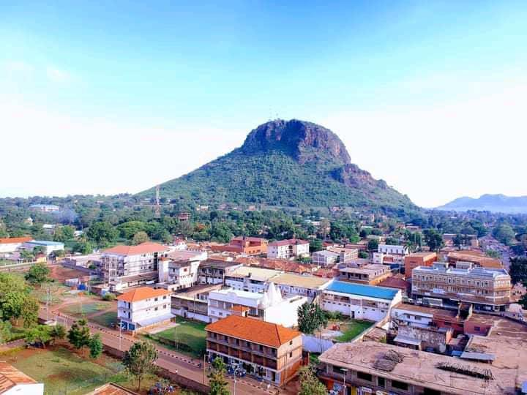

You have assumed the role of tour guide in TOUR WITH ME Company. A group of tourists from Europe are planning to visit your country. They have booked your company to help them tour certain areas of interest of which one of them is shown in the above photograph.

**Task:**

a) Draw a landscape sketch of the photograph and on it mark and name features found area shown in the photo.

b) Describe for the visitors the attractions they will see and the activities they will engage in when they visit the area.

c) How do locals benefit from tourists?

**SECTION B**

**Attempt all the numbers**

**Item 3:**

Namakula one of the adjudicators that judged the MDD competitions which was on the theme, Environmental conservation. It was held at Royal college Namugongo when the five houses were competing and the following are the results from the best House to the last house.

**Support material:**

|  |  |
| --- | --- |
| HOUSES | SCORES |
| Accra | 100 |
| Harare | 90 |
| Lagos | 80 |
| Kampala | 70 |
| Cairo | 60 |

**Task:**

1. Draw a suitable diagram to represent the information in the table below.
2. Explain any five ways how people conserve the environment.

**Item 4:**

1. Draw the shape of the earth and show different lines, poles and axes.
2. Mention any two effects of the Earth’s rotation.
3. Define the term;

i). Equinox

ii). Earth’s Rotation

iii). Earth’s Revolution

1. As a tour and travel agent, you are expecting guests from London which is located **00W** of **GMT** and they are setting off at **2:00pm**. At What time will they reach Entebbe International Airport that is **370 E**?

**END**